|  |  |
| --- | --- |
| Canon EOS 90D CameraCanon EOS 90D (Nhập khẩu,+ Lens 18-135mm f/3.5 - f/5.6 IS USM) Canon EOS 90D + 18-135mm Canon EOS 90D + 18-135mm 2 Canon EOS 90D + 18-55mm 2 Canon EOS 90D + 18-55mm 8 | **Featured information:**   * Sensor: APS-C * ISO range: 100 - 25600 (expandable 100 - 51200) * Resolution: 32.5MP * Wireless connection: WiFi   Price : $ 1400  **Specifications:**   * **Sensor Format:** APS-C (1.6x Crop Factor) * **Resolution:** 34.4 megapixels * **Size photo:** 6960 x 4640 * **Image Proportions:** 1:1, 3:2, 4:3, 16:9 * **Sensor Type:** CMOS * **Image Format:** JPEG, Raw * **Anti-Vibration:** Digital (Video Only) * **Lens Mount:** Canon EF-S |

**Description:**

#### **32.5MP APS-C CMOS Sensor and DIGIC 8 image processor**

Canon EOS 90D is considered a mid-range DSLR camera for those who want to improve their photography abilities. The camera has dimensions of 140.7 x 104.8 x 76.8 mm and weight of 701g and is designed with a 3.1 inch flip screen. This Canon camera is dust and moisture resistant, suitable for use when taking photos in many different weather conditions. Besides, the buttons are placed in convenient positions to help users be flexible during use.

#### **Stylish Design**

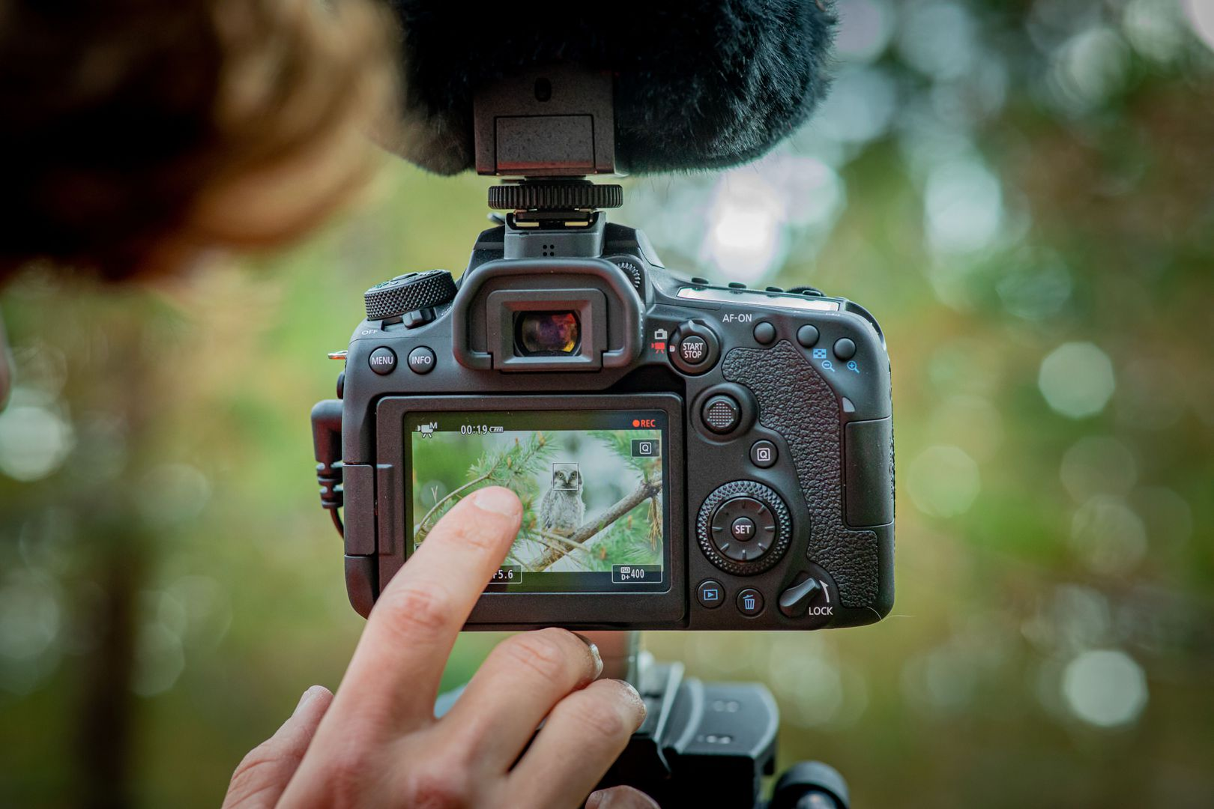

Canon EOS 90D can connect to smartphones via Bluetooth and Wifi. This feature allows you to easily share images/videos via your smartphone via the Canon Camera Connect app. In particular, you can adjust settings and change shooting modes on the camera through this application.